Name

Mathematics Advanced Year 11
Absolute Value Functions

Book 1 |  | Version: 261019  Feedback:  https://MrDingMaths.com
Contents
Syllabus Content 2
Learning Intention 3

Syllabus Content
MAV-11-02 uses functions and relations to model, analyse and solve problems
Absolute value functions
- Define the absolute value $\left|x\right|$ of a number $x$, also known as the magnitude of $x$, to be the distance from the origin to $x$ on the number line
- Establish and use the piecewise definition $\left|x\right|=\left\{\begin{matrix}x, \text{for} x≥0, \\ -x, \text{for} x<0\end{matrix}\right.$
- Show using numerical substitutions that $\sqrt{x^{2}}=\left|x\right|$ and use the result
- Graph the function $y=\left|x\right|$, describe its symmetry, and identify its domain and range
- Graph $y=\left|ax+b\right|$ with and without graphing applications, and identify its symmetry, domain and range
- Solve absolute value equations of the form $\left|ax+b\right|=k$ algebraically and graphically

Absolute Value

- Absolute Value
- The symbol $|x|$ represents the absolute value of $x$.
- A number’s absolute value, or magnitude, is its distance from zero on a number line.
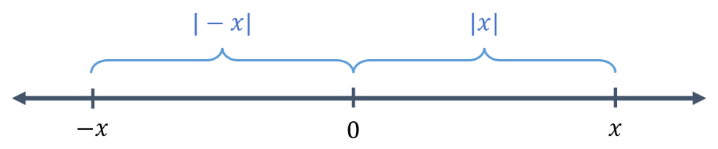

- Notice that the distance of $-x$ and $x$ from the origin is equal, so $\left|-x\right|=|x|$.
- Your calculator can evaluate numerical expressions involving absolute values.

FX-82 AU: FX8200 AU:


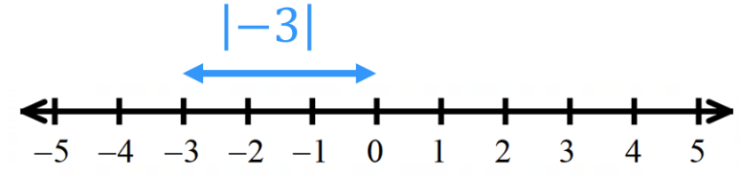
- Identify absolute value of an expression
$$\left|3\right|$$  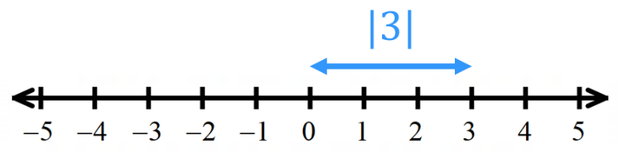 |  | $$\left|-3\right|$$
Evaluate:
- $\left|-15\right|$ | - $\left|34\right|$ | - $\left|-2.3\right|$ | - $\left|\frac{4}{-3}\right|$

- Absolute Value
- $|x-a|$ is the distance between $x$ and $a$ on a number line.
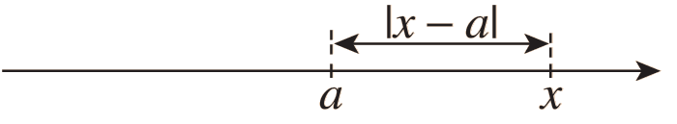

- We can evaluate the inside of the absolute value bracket, then apply the absolute value.

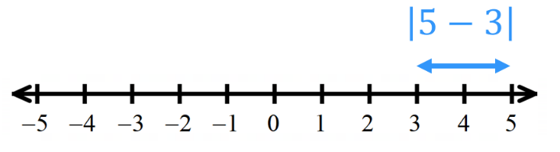
- Identify absolute value of an expression
$$\left|3-5\right| \\ =\left|-2\right| \\ =2$$  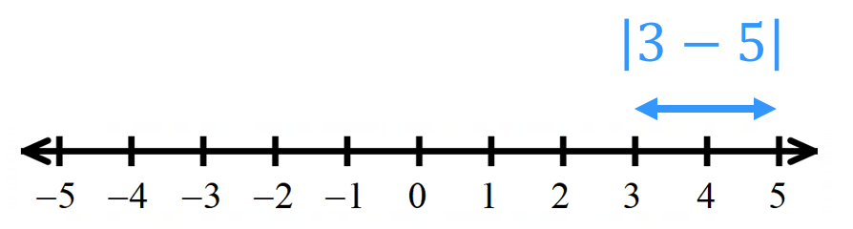 |  | $$\left|5-3\right| \\ =\left|2\right| \\ =2$$  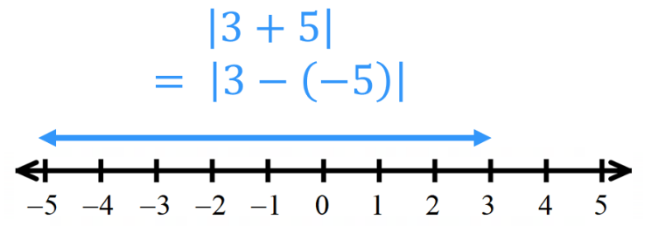
$$\left|-3-5\right| \\ =\left|-8\right| \\ =8$$  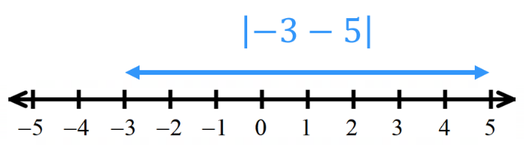 |  | $$\left|3+5\right| \\ =\left|8\right| \\ =8$$
Evaluate:
- $\left|8-3\right|$ | - $\left|3-8\right|$ | - $\left|-3-8\right|$ | - $\left|3+8\right|$
- $\left|-8-13\right|$ | - $\left|-41+23\right|$ | - $\left|86-88\right|$ | - $\left|-5-11\right|$

- Evaluating Absolute Value Expressions
- When evaluating absolute value expressions, follow the order of operations.
- Treat absolute value signs like brackets.
- Remember that you can check your answer on a calculator.

- Example Evaluate expressions involving absolute values
- $-1+|-2|$  $=-1+2$  $=1$ | - $3|-5|$  $=3\left|5\right|$  $$=15$$ | - $-2\left|3\left(-5\right)-16\right|$  $=-2\left|-15-16\right|$  $=-2\left|-31\right|$  $$=-62$$

- Guided Practice
Evaluate these expressions.
- $3|-8|$ | - $\left|-2\right|\left|8-3\right|$ | - $\left|-3\right|+|-1|$
- $\left|-6\right|-|-12|$ | - $\left|2\left(-3\right)-5\right|$ | - $|2-4\left(-3\right)|$

Foundation
- Evaluate these expressions.
- $|3|$  3 | - $\left|-3\right|$  3 | - $|4-7|$  3 | - $|7-4|$  3
- $|14-9-12|$  7 | - $\left|-7+8\right|$  1 | - $\left|3^{2}-5^{2}\right|$  16 | - $\left|11-16\right|-8$  $$-3$$
- $\left|2×-7\right|$  14 | - $\left|-3\right|+\left|-1\right|$  4 | - $5-\left|-2\right|×{\left|6\right|}^{2}$  $$-67$$ | - $\left|-2×5×-1\right|$  7
- $3\left|-4\right|$  12 | - $2\left|-3\right|-3\left|-4\right|$  $$-6$$ | - $\left|5-7\right|+4\left|-2\right|$  10 | - $-\left|2×-5+3\right|$  $$-7$$

- Show that $\left|a+b\right|≤\left|a\right|+\left|b\right|$ by evaluating LHS and RHS of the inequality for each question.
- $a=2, b=4$  $$LHS =\left|2+4\right|$$  $=$  $$RHS=\left|2\right|+\left|4\right|$$  $=$ | - $a=-1, b=-2$ | - $a=-2, b=3$
- $a=-4, b=5$ | - $a=-7, b=-3$

Absolute Value as a Piecewise-Defined Function

- Absolute Value as a Piecewise-Defined Function
We can define the absolute value as a piecewise-defined function:
$$\left|x\right|=\left\{\begin{matrix}x, \text{for} x≥0, \\ -x, \text{for} x<0\end{matrix}\right.$$
More generally:
$$\left|f\left(x\right)\right|=\left\{\begin{matrix}f\left(x\right), \text{for} f\left(x\right)≥0, \\ -f\left(x\right), \text{for} f\left(x\right)<0\end{matrix}\right.$$

To write an absolute value expression as a piecewise function
- Write $\left|f\left(x\right)\right|=\left\{\begin{matrix}f\left(x\right), \text{for} f\left(x\right)≥0, \\ -f\left(x\right), \text{for} f\left(x\right)<0\end{matrix}\right.$
- Simplify as much as possible.

- Example Write an absolute value expression as a piecewise function
Worked Example | Your Turn
$$\left|3x\right|$$  1. $\left|3x\right|=\left\{\begin{matrix}3x, \text{for} 3x≥0, \\ -3x, \text{for} 3x<0\end{matrix}\right.$  2. $\left|3x\right|=\left\{\begin{matrix}3x, \text{for} x≥0, \\ -3x, \text{for} x<0\end{matrix}\right.$ | $$\left|4x\right|$$  $$\left|4x\right|=\left\{\begin{matrix}4x, \text{for} x≥0, \\ -4x, \text{for} x<0\end{matrix}\right.$$
$$\left|x+3\right|$$  1. $\left|x+3\right|=\left\{\begin{matrix}x+3, \text{for} x+3≥0, \\ -\left(x+3\right), \text{for} x+3<0\end{matrix}\right.$  2. $\left|x+3\right|=\left\{\begin{matrix}x+3, \text{for} x≥-3, \\ -x-3, \text{for} x<-3\end{matrix}\right.$ | $$\left|x-4\right|$$  $$\left|x-4\right|=\left\{\begin{matrix}x-4, \text{for} x≥4, \\ -x+4, \text{for} x<4\end{matrix}\right.$$
$$\left|2x-7\right|$$  1. $\left|2x-7\right|=\left\{\begin{matrix}2x-7, \text{for} 2x-7≥0, \\ -\left(2x-7\right), \text{for} 2x-7<0\end{matrix}\right.$  2. $\left|2x-7\right|=\left\{\begin{matrix}2x-7, \text{for} x≥\frac{7}{2}, \\ -2x+7, \text{for} x<\frac{7}{2}\end{matrix}\right.$ | $$\left|3x+4\right|$$  $$\left|3x+4\right|=\left\{\begin{matrix}3x+4, \text{for} x≥-\frac{4}{3}, \\ -3x-4, \text{for} x<-\frac{4}{3}\end{matrix}\right.$$

Foundation
- Write each absolute value expression as a piecewise-defined function.
- $\left|x+5\right|$  $$\left|x+5\right|=\left\{\begin{matrix}x+5, \text{for} x≥-5, \\ -x-5, \text{for} x<-5\end{matrix}\right.$$ | - $\left|b-3\right|$  $$\left|b-3\right|=\left\{\begin{matrix}b-3, \text{for} x≥3, \\ -b+3, \text{for} x<3\end{matrix}\right.$$
- $\left|2y-6\right|$  $$\left|2y-6\right|=\left\{\begin{matrix}2y-6, \text{for} y≥3, \\ -2y+6, \text{for} y<3\end{matrix}\right.$$ | - $\left|3x+9\right|$  $$\left|3x+9\right|=\left\{\begin{matrix}3x+9, \text{for} x≥-3, \\ -3x-9, \text{for} x<-3\end{matrix}\right.$$
- $\left|4-x\right|$  $$\left|4-x\right|=\left\{\begin{matrix}4-x, \text{for} x≤4, \\ x-4, \text{for} x>4\end{matrix}\right.$$ | - $\left|2k+1\right|$  $$\left|2k+1\right|=\left\{\begin{matrix}2k+1, \text{for} k≥-\frac{1}{2}, \\ -2k-1, \text{for} k<-\frac{1}{2}\end{matrix}\right.$$
- $\left|5x-2\right|$  $$\left|5x-2\right|=\left\{\begin{matrix}5x-2, \text{for} x≥\frac{2}{5}, \\ -5x+2, \text{for} x<\frac{2}{5}\end{matrix}\right.$$ | - $\left|ax+b\right|$  $$\left|ax+b\right|=\left\{\begin{matrix}ax+b, \text{for} x≥-\frac{b}{a}, \\ -ax-b, \text{for} x<-\frac{b}{a}\end{matrix}\right.$$

- By writing each function as a piece-wise defined function, or otherwise, write an expression for:
- $\left|a\right|$ when $a≥0$  $$a$$ | - $\left|a\right|$ when $a<0$  $$-a$$ | - $\left|3a\right|$ when $a<0$  $$-3a$$
- $\left|a+1\right|$ when $a>-1$  $$a+1$$ | - $\left|a+1\right|$ when $a<-1$  $$-a-1$$ | - $\left|x-2\right|$ when $x>2$  $$x-2$$

Foundation
- Write each absolute value expression as a piecewise-defined function.
- $\left|x+5\right|$  $$\left|x+5\right|=\left\{\begin{matrix}x+5, \text{for} x≥-5, \\ -x-5, \text{for} x<-5\end{matrix}\right.$$ | - $\left|b-3\right|$  $$\left|b-3\right|=\left\{\begin{matrix}b-3, \text{for} x≥3, \\ -b+3, \text{for} x<3\end{matrix}\right.$$
- $\left|2y-6\right|$  $$\left|2y-6\right|=\left\{\begin{matrix}2y-6, \text{for} y≥3, \\ -2y+6, \text{for} y<3\end{matrix}\right.$$ | - $\left|3x+9\right|$  $$\left|3x+9\right|=\left\{\begin{matrix}3x+9, \text{for} x≥-3, \\ -3x-9, \text{for} x<-3\end{matrix}\right.$$
- $\left|4-x\right|$  $$\left|4-x\right|=\left\{\begin{matrix}4-x, \text{for} x≤4, \\ x-4, \text{for} x>4\end{matrix}\right.$$ | - $\left|2k+1\right|$  $$\left|2k+1\right|=\left\{\begin{matrix}2k+1, \text{for} k≥-\frac{1}{2}, \\ -2k-1, \text{for} k<-\frac{1}{2}\end{matrix}\right.$$
- $\left|5x-2\right|$  $$\left|5x-2\right|=\left\{\begin{matrix}5x-2, \text{for} x≥\frac{2}{5}, \\ -5x+2, \text{for} x<\frac{2}{5}\end{matrix}\right.$$ | - $\left|ax+b\right|$  $$\left|ax+b\right|=\left\{\begin{matrix}ax+b, \text{for} x≥-\frac{b}{a}, \\ -ax-b, \text{for} x<-\frac{b}{a}\end{matrix}\right.$$

- By writing each function as a piece-wise defined function, or otherwise, write an expression for:
- $\left|a\right|$ when $a≥0$  $$a$$ | - $\left|a\right|$ when $a<0$  $$-a$$ | - $\left|3a\right|$ when $a<0$  $$-3a$$
- $\left|a+1\right|$ when $a>-1$  $$a+1$$ | - $\left|a+1\right|$ when $a<-1$  $$-a-1$$ | - $\left|x-2\right|$ when $x>2$  $$x-2$$

Absolute Value Equations

- Solving Absolute Value Equations
- An absolute value equation has the form $\left|ax+b\right|=k$
- Using the fact that
$\left|ax+b\right|=k$ and $\left|-\left(ax+b\right)\right|=k$
we remove the absolute value signs by considering two cases:
Case 1: $ax+b$ is positive  $$ax+b=k$$ | Case 2: $ax+b$ is negative  $$-\left(ax+b\right)=k$$
- Never make the habit of writing
$$\left|ax+b\right|=k \\ ax+b=±k$$
as this leads to mistakes when solving inequalities.

- Example Solve absolute value equations
$$|x|=2$$ | $$\left|2x+3\right|=2$$
  $x=2$ | $-x=2$  $x=-2$
  $2x+3=2$  $2x=-1$  $$x=-\frac{1}{2}$$ | $-\left(2x+3\right)=2$  $2x+3=-2$  $2x=-5$  $$x=-\frac{5}{2}$$

- Guided Practice
Solve:
- $\left|x-3\right|=5$ | - $\left|2-3x\right|=5$
- $\left|2x+1\right|-4=11$ | - $\left|x+1\right|=-2$

- Solving Absolute Value Equations
When there are variables on both sides, sometimes the algebra introduces an extra solution.
Always verify your solutions by substituting back into the original.
We will see where these extraneous solutions come from when we solve graphically.

- Example Find the equation of an absolute value graph $y=\left|ax+b\right|$
Solve $\left|x+3\right|=2x-1$
$$x+3=2x-1 \\ 4=x$$  Checking $x=4:$  $$\left|4+3\right|=2\left(4\right)-1 \\ 7=7 ✓$$ | $$-\left(x+3\right)=2x-1 \\ -x-3=2x-1 \\ -2=3x \\ x=-\frac{2}{3}$$  Checking $x=-$ $\frac{2}{3}$  $$\left|-\frac{2}{3}+3\right|=2\left(-\frac{2}{3}\right)-1 \\ \frac{7}{3}=-\frac{7}{3} ✗$$
Only $x=4$ is a solution.

- Guided Practice
Solve $\left|x-3\right|=2x$

$$x=1$$
Solve $\left|3x-1\right|=x+13$

$$x=3 or-7$$

Foundation
- Solve each absolute value equation.
- $\left|x\right|=1$  $x=1$ or $-1$ | - $\left|x\right|=3$  $x=3$ or $-3$ | - $\left|4x\right|=8$  $x=2$ or $-2$
- $\left|2x\right|=10$  $x=1$ or $-1$ | - $\left|2x\right|=-6$  No solution | - $\left|x-4\right|=1$  $x=3$ or $5$
- $\left|x-3\right|=7$  $x=-4$ or $10$ | - $\left|x-7\right|=-2$  No solution | - $\left|x+5\right|=2$  $x=-3$ or $-7$
- $\left|x+2\right|=2$  $x=-4$ or $0$ | - $\left|x+1\right|=6$  $x=-7$ or $5$ | - $\left|x+3\right|=1$  $x=-4$ or $-2$

- Solve these equations.
- $\left|x-9\right|=3$  $x=12$ or $6$ | - $\left|5-x\right|=3$  $x=8$ or $2$ | - $\left|2x+1\right|=13$  $x=6$ or $-7$
- $\left|3-2x\right|=11$  $x=7$ or $-4$ | - $\left|\frac{x+2}{5}\right|$ $=1$  $x=3$ or $-7$ | - $\left|\frac{2x+5}{3}\right|$ $=5$  $x=5$ or $-10$

Sketching Absolute Value Functions

- Graph absolute value functions
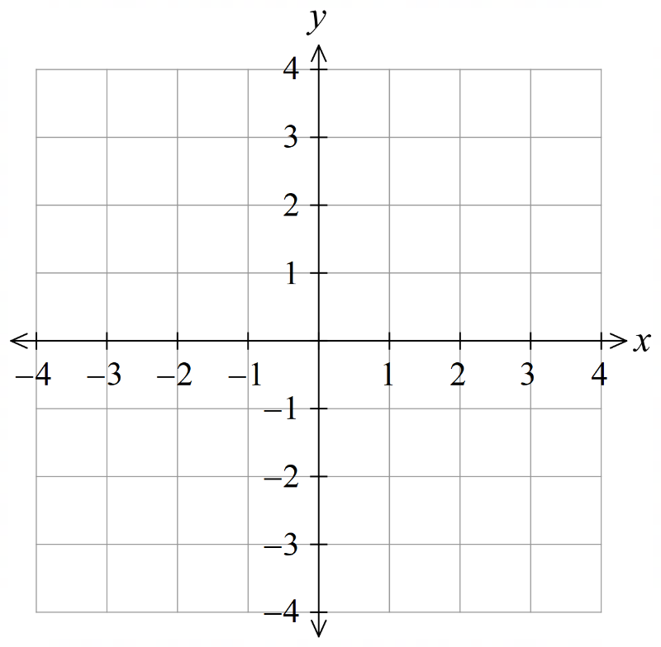
Draw the graph of $y=|x|$
$$x$$ | $$-3$$ | $$-2$$ | $$-1$$ | $$0$$ | $$1$$ | $$2$$ | $$3$$
$$y$$

What is the domain of $y=\left|x\right|$?
What is the range of $y=\left|x\right|$?
Write the piecewise definition of $y=\left|x\right|.$
$\left|x\right|=$
How does this relate to the graph?
To the left of ………, the graph is the line ……………
To the right of ………, the graph is the line ……………

Draw the graph of $y=|2x+6|$
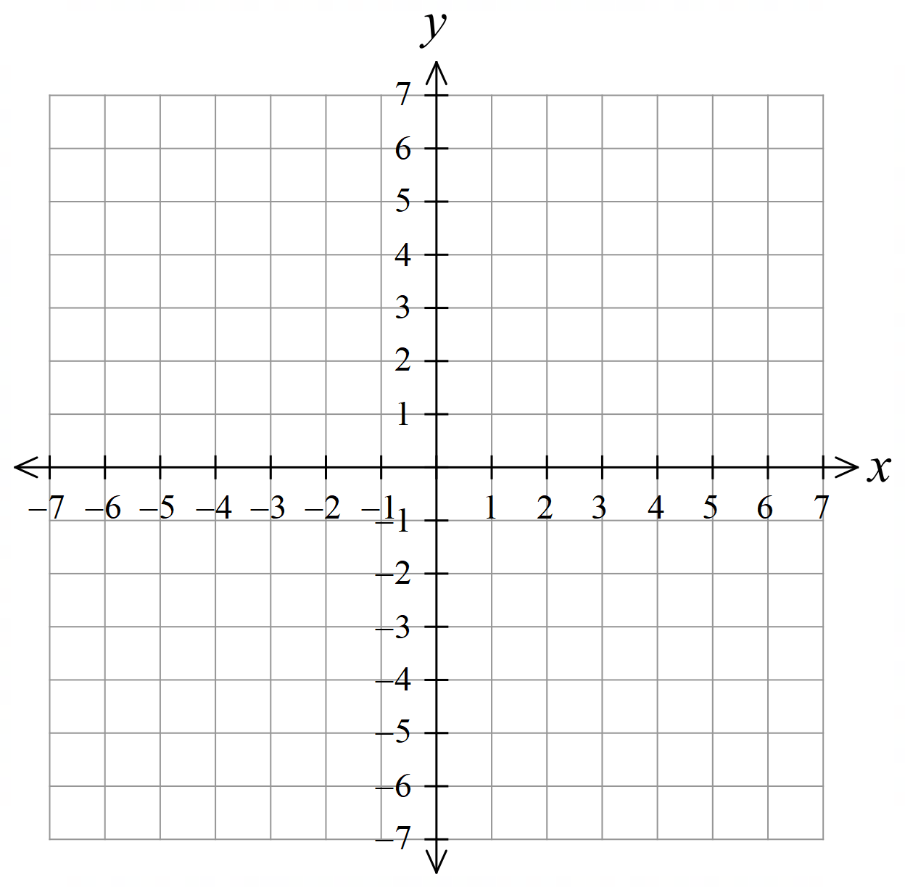
$$x$$ | $$-3$$ | $$-2$$ | $$-1$$ | $$0$$ | $$1$$ | $$2$$ | $$3$$
$$y$$

Domain:
Range:
Write the piecewise definition of $y=\left|2x+6\right|.$
$\left|2x+6\right|=$
How does this relate to the graph?
To the left of ………, the graph is the line ……………
To the right of ………, the graph is the line ……………
In general, if we write an absolute value function as a piecewise function, each “branch” of the absolute value function is one of the s……f………………
What do you notice about the graph of $y=\left|2x+6\right|$ compared to $y=2x+6$?
In $y=|2x+6|$, the $y$ values of $y=2x+6$ that would be n…………………… are r…………………… above the ……-axis.
- Sketching Absolute Value Graphs
To sketch $y=|ax+b|$:
- Determine $y$-intercept by letting $x=0$.
- Determine $x$-intercept by letting $y=0$.
- Use the symmetrical V shape to sketch the graph.
Check your answer using your knowledge of the gradient and $y$-intercept of $y=ax+b$.

- Example Sketch absolute value graphs
Sketch $y=|4x+7|$  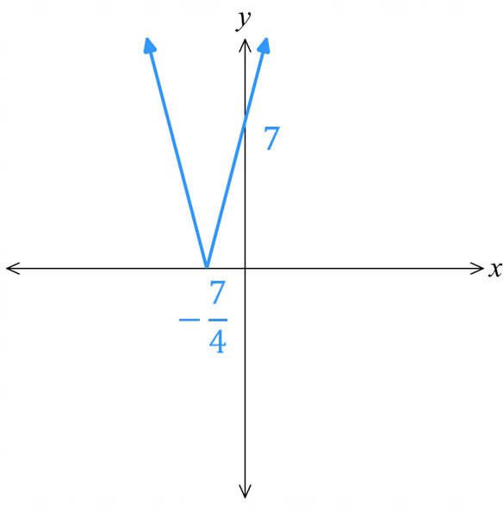  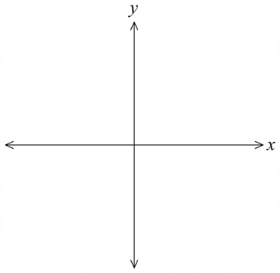  1. $y$ intercept  $y=|4\left(0\right)+7|$  $=7$  2. $x$ intercept  $0=|4x+7|$  $0=4x+7$  $-7=4x$  $$-\frac{7}{4}=x$$ | Sketch $y=-\left|3x-6\right|$  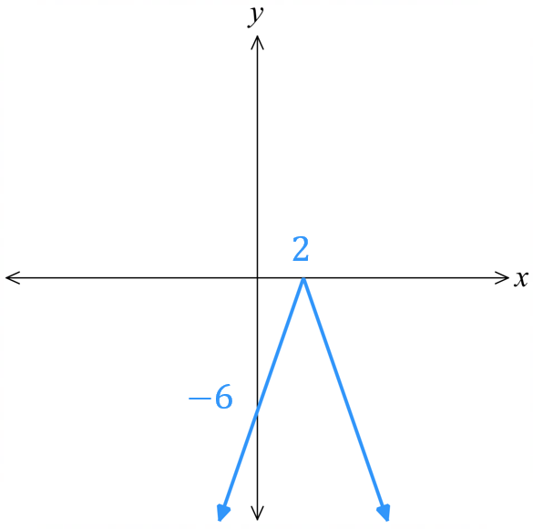  1. $y$ intercept  $y=-|-3\left(0\right)-6|$  $$=-6$$  2. $x$ intercept  $0=-|3x-6|$  $0=3x-6$  $3x=6$  $$x=2$$

- Guided Practice
Sketch
- $y=|x-3|$ | $$y=|2x|$$
- $y=-|2x-6|$ | $$y=|9-3x|$$
- Translation of Absolute Value Graphs
$y=\left|ax+b\right|+c$ is shifted vertically by $c,$ with turning point at $\left(-\frac{b}{a},c\right)$.
You can find the intercepts, or you can sketch using the piecewise definition:
$$\left|ax+b\right|+c=\left\{\begin{matrix} ax+b+c, \text{for} x≥-\frac{b}{a}, \\ -ax-b+c , \text{for} x<-\frac{b}{a}\end{matrix}\right.$$
In the previous examples, $y=\left|ax+b\right|$, the turning point was the $x$-intercept $-$ $\frac{b}{a}$

- Example Find the equation of an absolute value graph $y=\left|ax+b\right|$
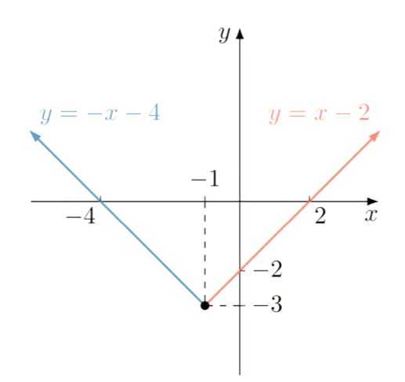
Sketch $y=\left|x+1\right|-3$
1. $y$ intercept
$$y=\left|0+1\right|-3$$
$=-2$

2. $x$ intercept
$0=\left|x+1\right|-3$
$3=\left|x+1\right|$

$$x+1=3 or -\left(x+1\right)=3$$
$x=2 -x-1=3$
$x=-4$

3. turning point
$$\left(-1,-3\right)$$

Notice that the left branch is $y=-x-4$ and the right branch is $y=x-2$

- Guided Practice
Sketch $y=\left|x-5\right|+1$

- Finding the Equation of an Absolute Value Graph
To find $y=\left|ax+b\right|$,
1. Consider either the positive branch $y=ax+b$ or the negative branch $y=-\left(ax+b\right).$
Choose the branch where you have at least two points.
2. Find the gradient $a$ and $y$-intercept $b$.
3. Write $y=\left|ax+b\right|$

- Example Find the equation of an absolute value graph $y=\left|ax+b\right|$
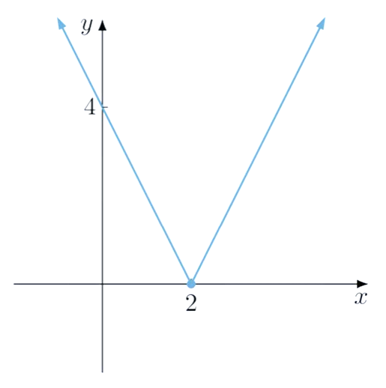 | 1. Consider the negative branch  2. $a=$ $\frac{-4}{2}$ $=-2$  $b=4$  3. $y=\left|-2x+4\right|$ or $y=\left|2x-4\right|$

- Guided Practice
Find the equation of these absolute value graphs in the form $y=\left|ax+b\right|$
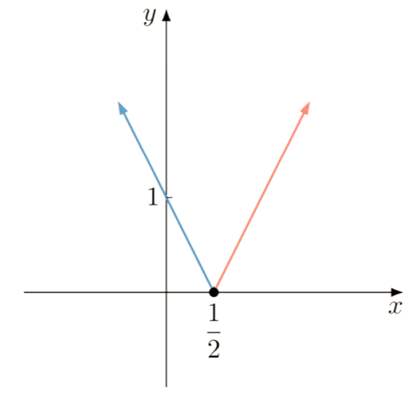  $$y=\left|2x+1\right|$$ | 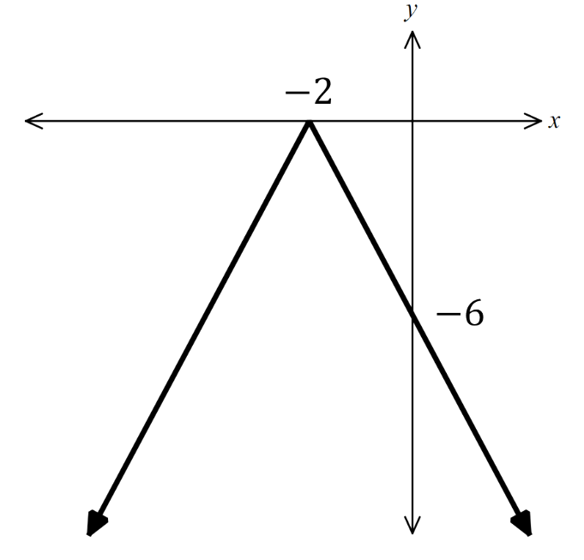  $$y=-\left|3x+6\right|$$

Foundation
- Sketch these absolute value functions, using symmetry. Show all intercepts.
- $y=\left|2x\right|$  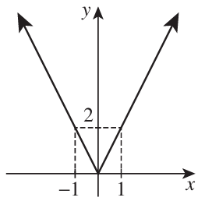 | - $y=\left|\frac{x}{2}\right|$  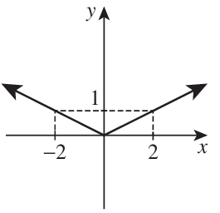  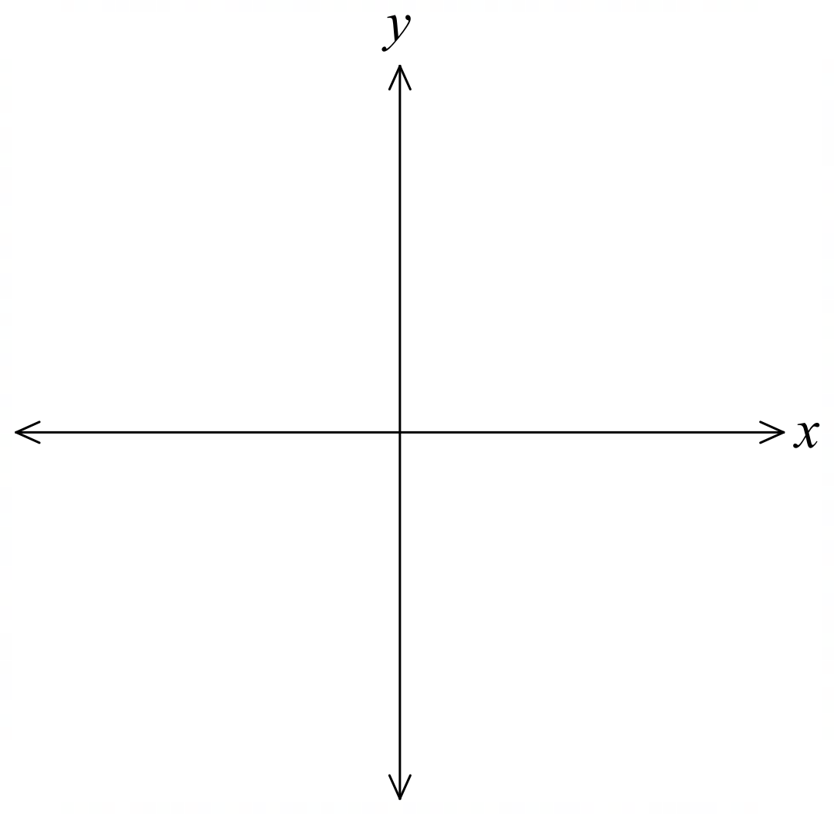 | - $y=\left|x-3\right|$  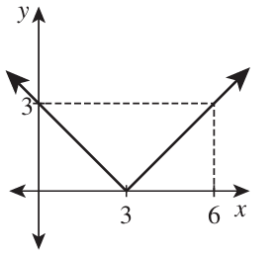
- $y=\left|x+2\right|$  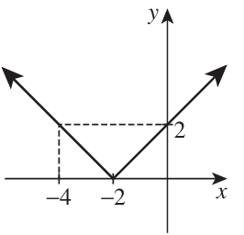 | - $y=\left|2x-6\right|$  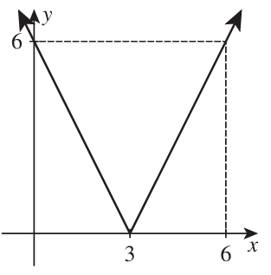 | - $y=\left|9-3x\right|$  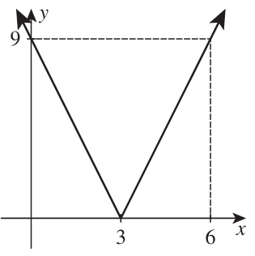
- $y=\left|4x+10\right|$  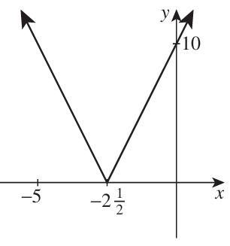 | - $y=-\left|3x+7\right|$  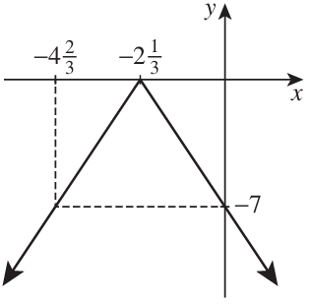 | - $y=-\left|7x\right|$  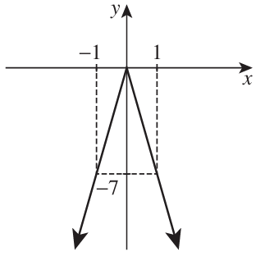
- $y=\left|3-x\right|$  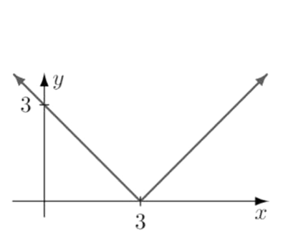 | - $y=\left|3x+6\right|$  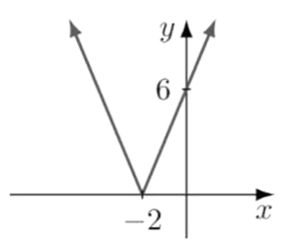 | - $y=\left|\frac{x}{2}+2\right|$  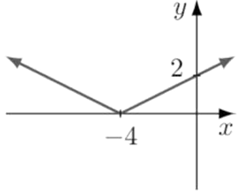

Development
- These diagrams show the graph of absolute value functions in the form $f\left(x\right)=\left|ax+b\right|$.
Find the equation of each one by finding the equation of a linear “branch” of the graph.
$$f\left(x\right)=\left|2x\right|$$ | 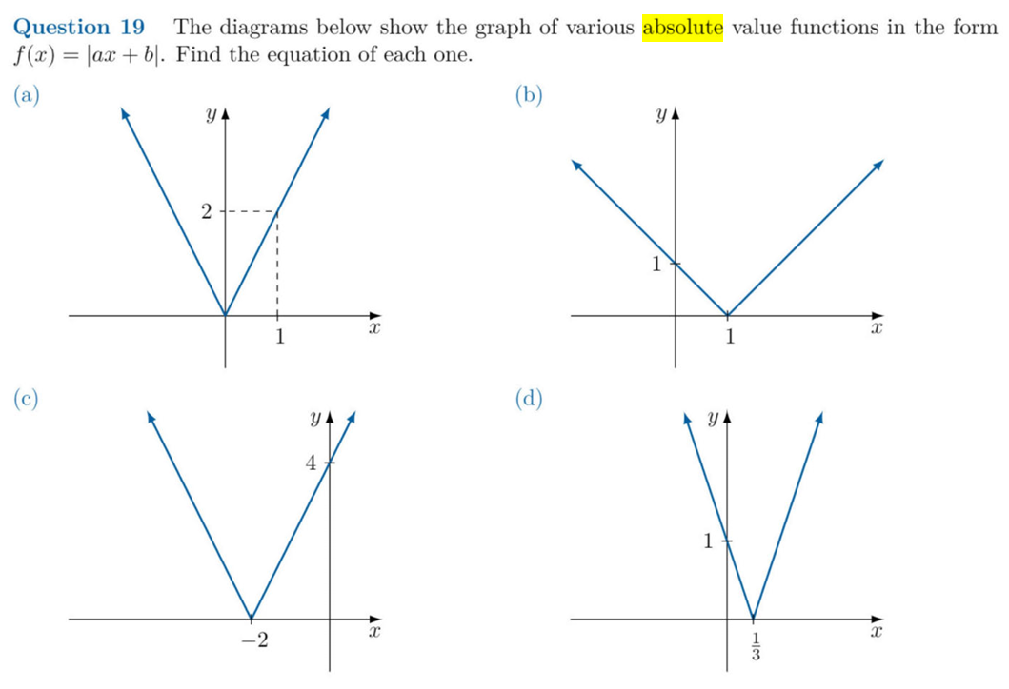  $$f\left(x\right)=\left|x-1\right|$$
$$f\left(x\right)=\left|2x+4\right|$$ | $$f\left(x\right)=\left|3x-1\right|$$

- Decide whether these functions are odd, even, or neither.
You may need to use $\left|-x\right|=\left|x\right|$ and $\left|x-y\right|=\left|y-x\right|$. Check your answer using DESMOS.
- $f\left(x\right)=\left|x\right|+1$  even | - $f\left(x\right)=\left|x\right|+x$  neither
- $f\left(x\right)=x×\left|x\right|$  odd | - $f\left(x\right)=\left|x^{3}+x\right|$  even
- $f\left(x\right)=$ $\frac{x}{\left|x\right|-x}$  neither | - $f\left(x\right)=\left|x-1\right|+\left|x+1\right|$  even

Mastery
- Consider the function:
$$f\left(x\right)=\frac{\left|x\right|}{x}$$
  - Complete the following:
$$\frac{\left|x\right|}{x}=\left\{\begin{matrix} , \text{for} x>0, \\ , \text{for} x<0\end{matrix}\right.$$
1
$$-1$$
  - Why can’t $x=0$?
$x$ is the term in the denominator. Cannot divide by 0.
  - Complete the table of values and hence sketch the function.
$$x$$ | $$-2$$ | $$-1$$ | $$0$$ | $$1$$ | $$2$$
$$y$$
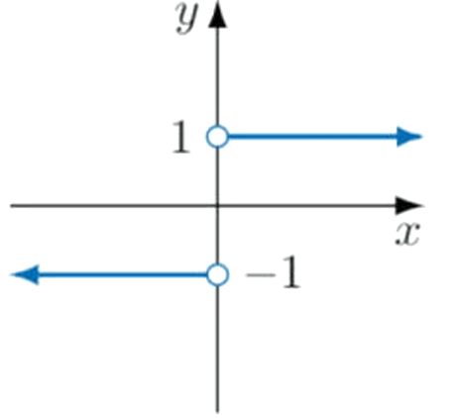

Use a similar technique to sketch these functions:
- $f\left(x\right)=x+\left|x\right|$  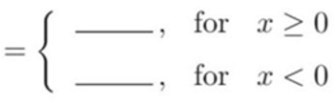  $x+\left|x\right|$  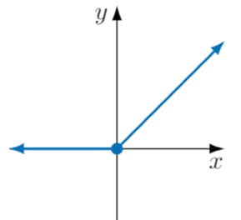 | - $f\left(x\right)=x-\left|x\right|$  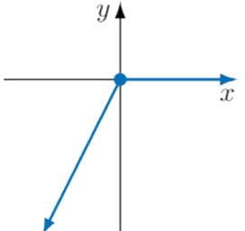 | - $f\left(x\right)=x×|x|$  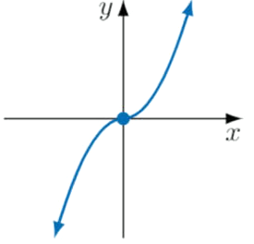

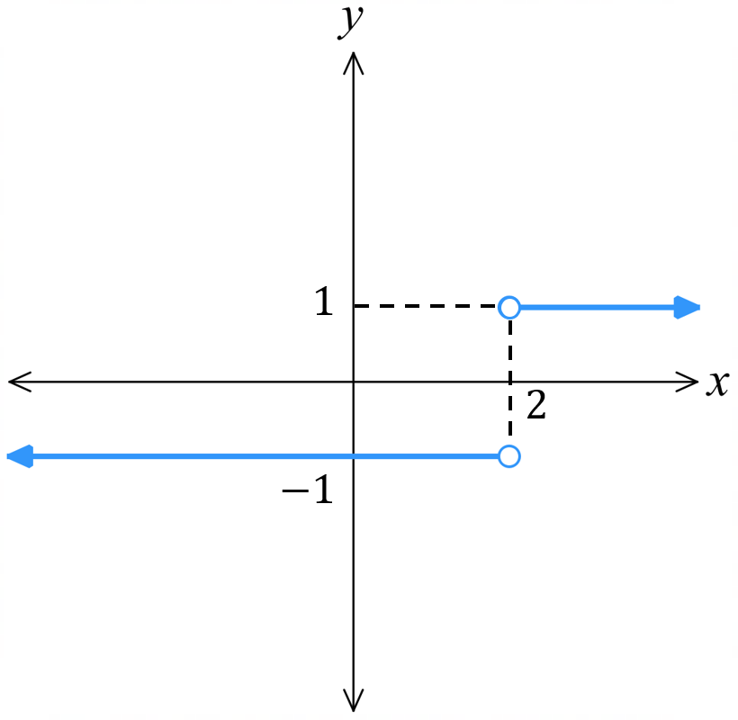
- Simplify this expression $\frac{x-2}{\left|x-2\right|}$ and hence sketch $y=$ $\frac{x-2}{\left|x-2\right|}$.

$$\frac{x-2}{|x-2|}=\left\{\begin{matrix}1, \text{for} x>2, \\ -1, \text{for} x<2\end{matrix}\right.$$
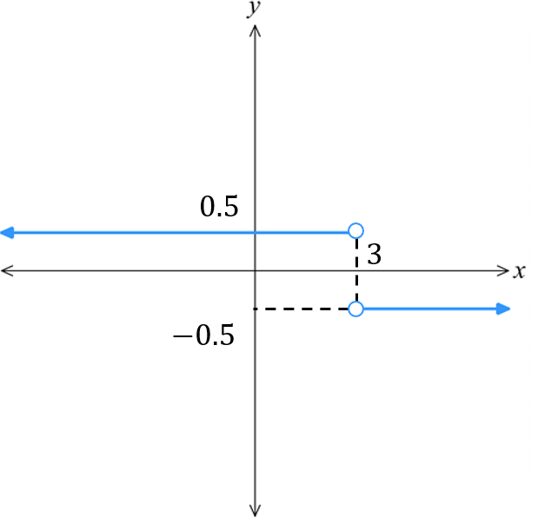
- Simplify this expression $\frac{|x-3|}{6-2x}$ and hence sketch $y=$ $\frac{|x-3|}{6-2x}$.

$$\frac{x-3}{6-2x}=\left\{\begin{matrix}0.5, \text{for} x<3, \\ -0.5, \text{for} x>3\end{matrix}\right.$$
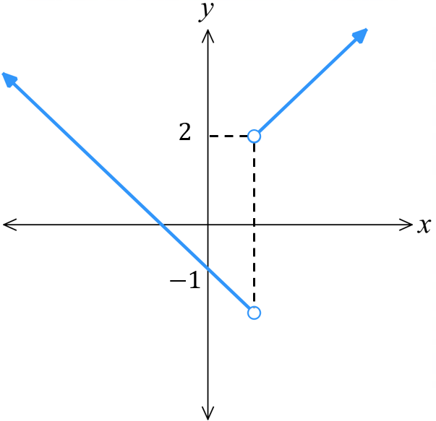
- Simplify $f\left(x\right)=$ $\frac{x^{2}-1}{\left|x-1\right|}$ and hence sketch $y=f\left(x\right)$.

$$\frac{x^{2}-1}{\left|x-1\right|}=\left\{\begin{matrix}x+1, \text{for} x>1, \\ -x-1, \text{for} x<1\end{matrix}\right.$$

Solving Absolute Value Equations Graphically

- Solving Absolute Value Equations Graphically
Recall that any equation can be solved graphically using these steps:
1. Sketch $y=LHS$ and $y=RHS.$
2. Identify the points of intersection.
3. Read off the $x$ coordinates of the points of intersection.
This requires an accurate graph.
A quick sketch can also be useful for verifying solutions.

- Example Solve absolute value equations graphically
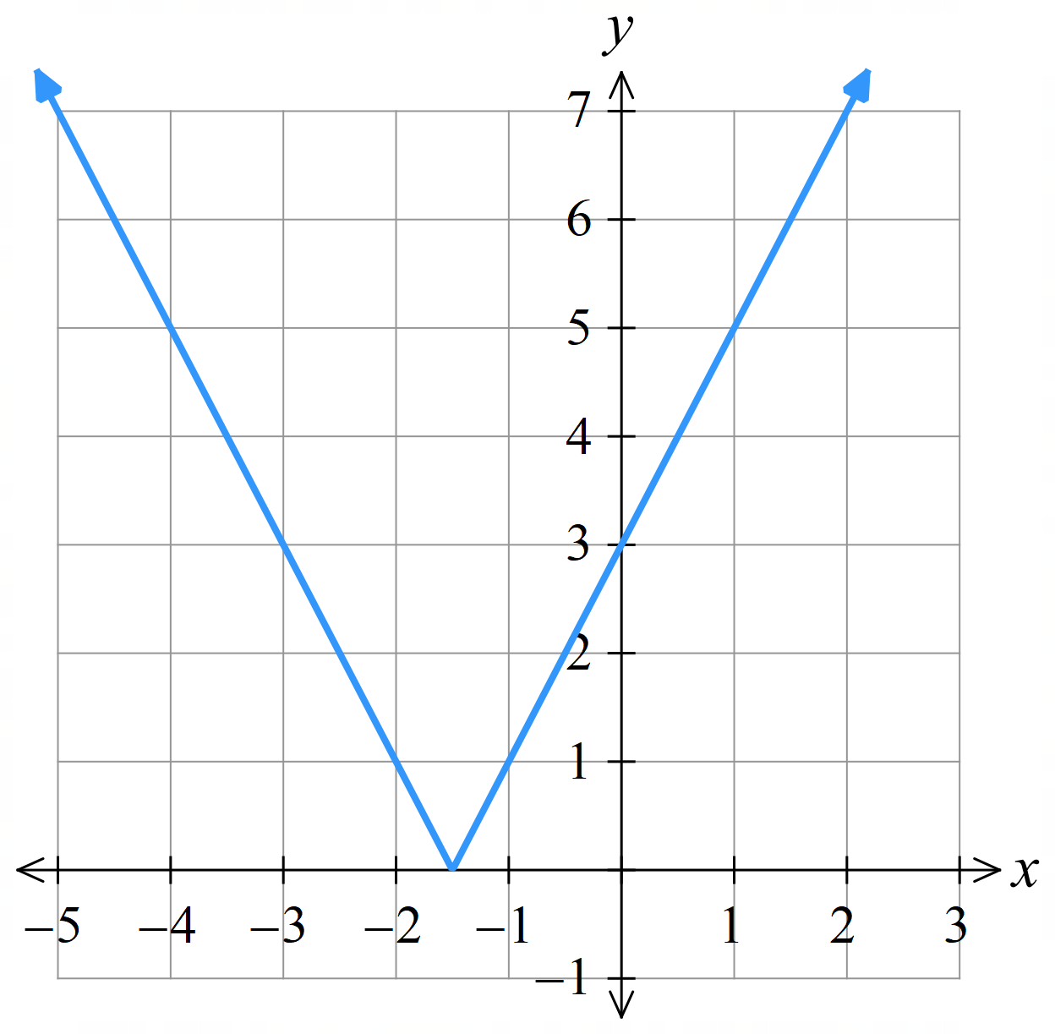
The graph of $y=|2x+3|$ is given.
Solve $\left|2x+3\right|=5$graphically.

1. Sketch $y=5$. | 2. Identify POI. | 3. Read $x$-values.
The solutions are $x=-4$ and $x=1$.
Verify algebraically:
$$\left|2x+3\right|=5$$
$$2x+3=5 \\ 2x=2 \\ x=1$$ | $$-\left(2x+3\right)=5 \\ -2x-3=5 \\ -2x=8 \\ x=-4$$

- Guided Practice
$y=LHS$ is given. Solve these equations graphically, then verify your answers algebraically.
- $\left|2x-5\right|=2$
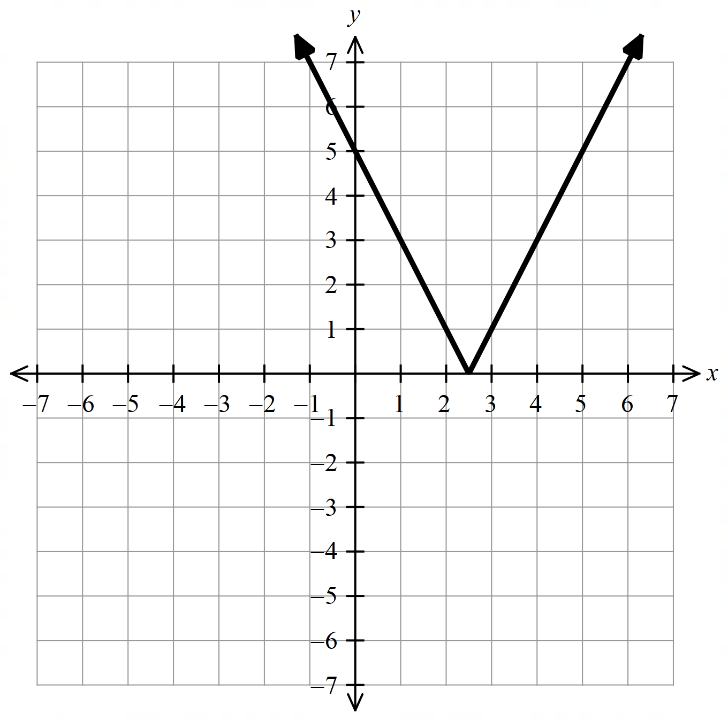

- $\left|-\frac{x}{2}\right|+1=-\frac{3}{2}$
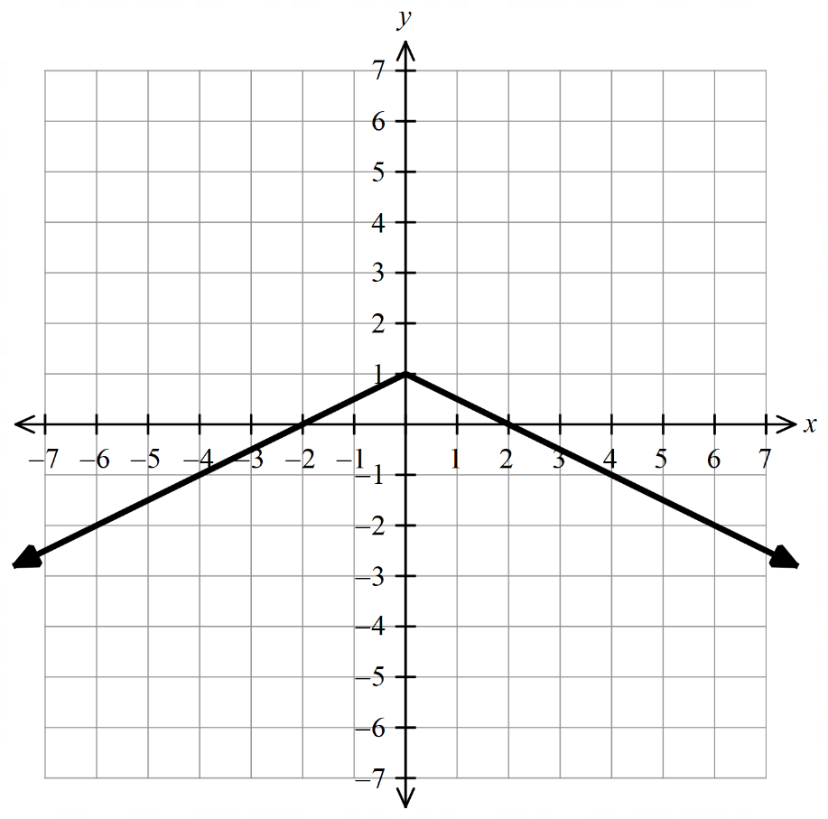

- $\left|2x+3\right|=6-2x$
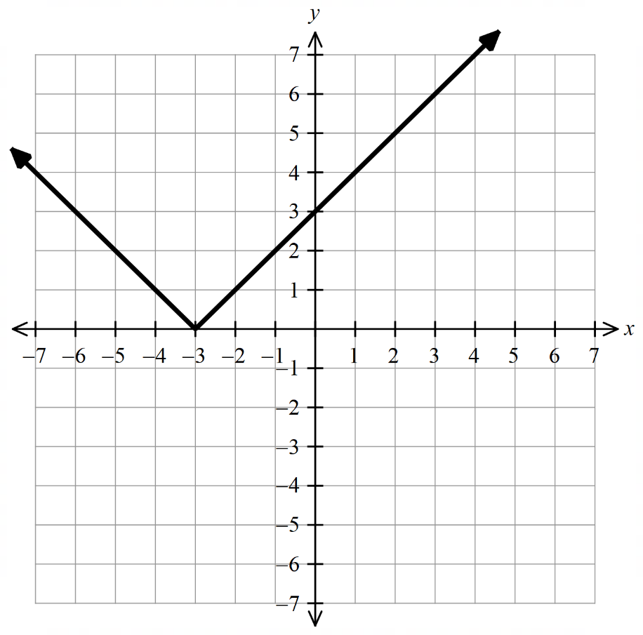

Foundation
- Solve these equations. Use the sketches to check your answer.
- $\left|2x-1\right|=3$  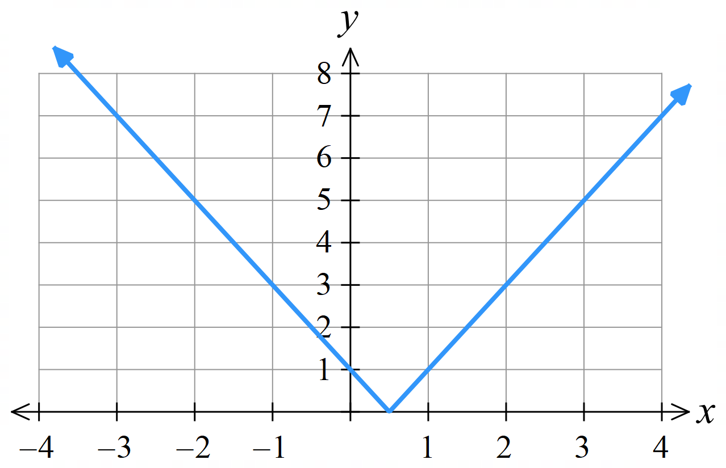  $x=-1$ or $2$ | - $\left|3-2x\right|=5$  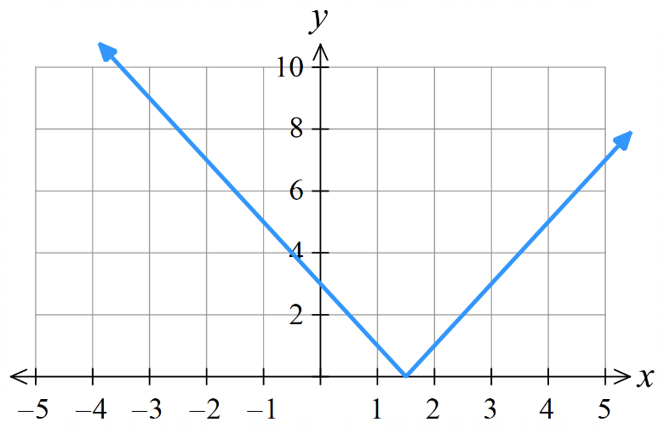  $x=4$ or $-1$
- $\left|3x+5\right|=16$  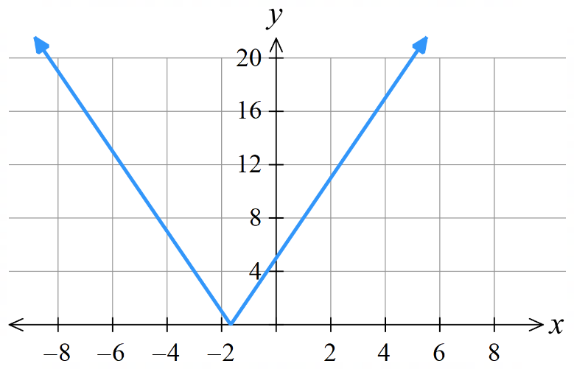  $x=-7$ or $\frac{11}{3}$ | - $\left|1-2x\right|=5$  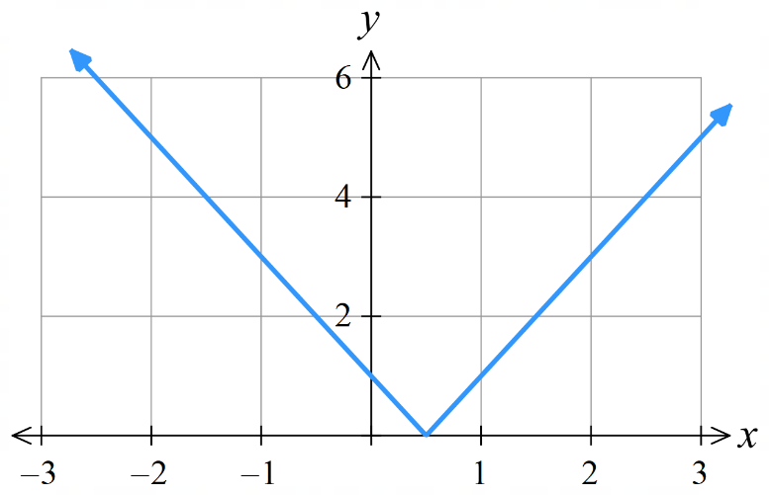  $x=3$ or $-2$
- $-\left|2x+1\right|+5=3$  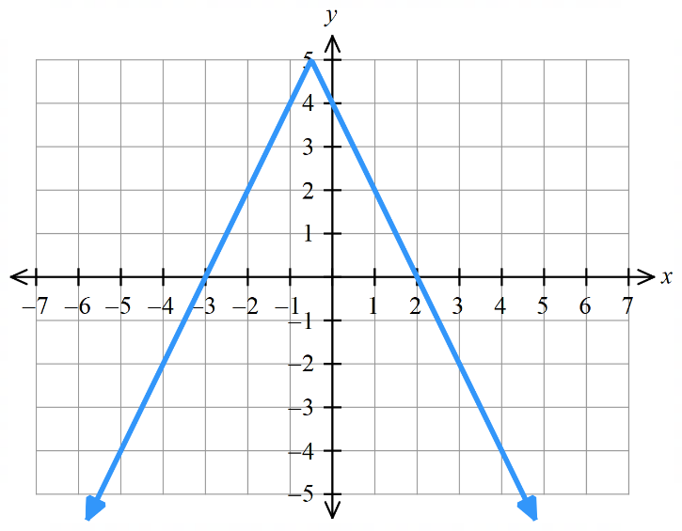  $$x=-1.5, 0.5$$ | - $\left|x+1\right|-3=0$  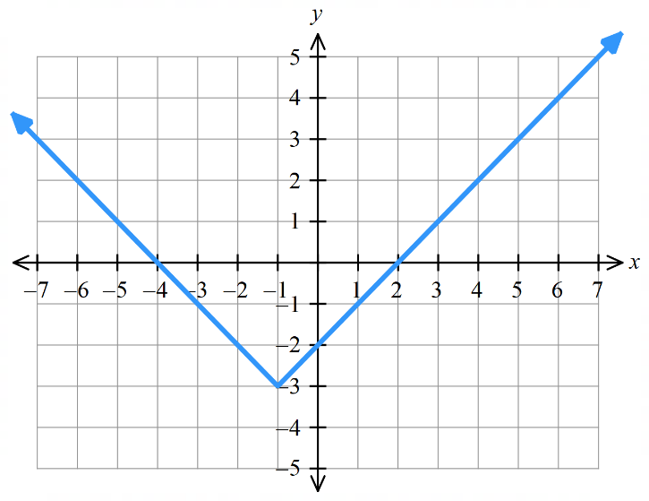  $$x=-4, 2$$

  - On the same set of axes, sketch $y=\left|x-2\right|$ and $y=$ $\frac{x}{3}$
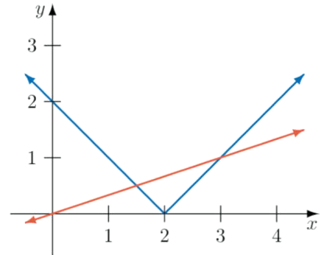
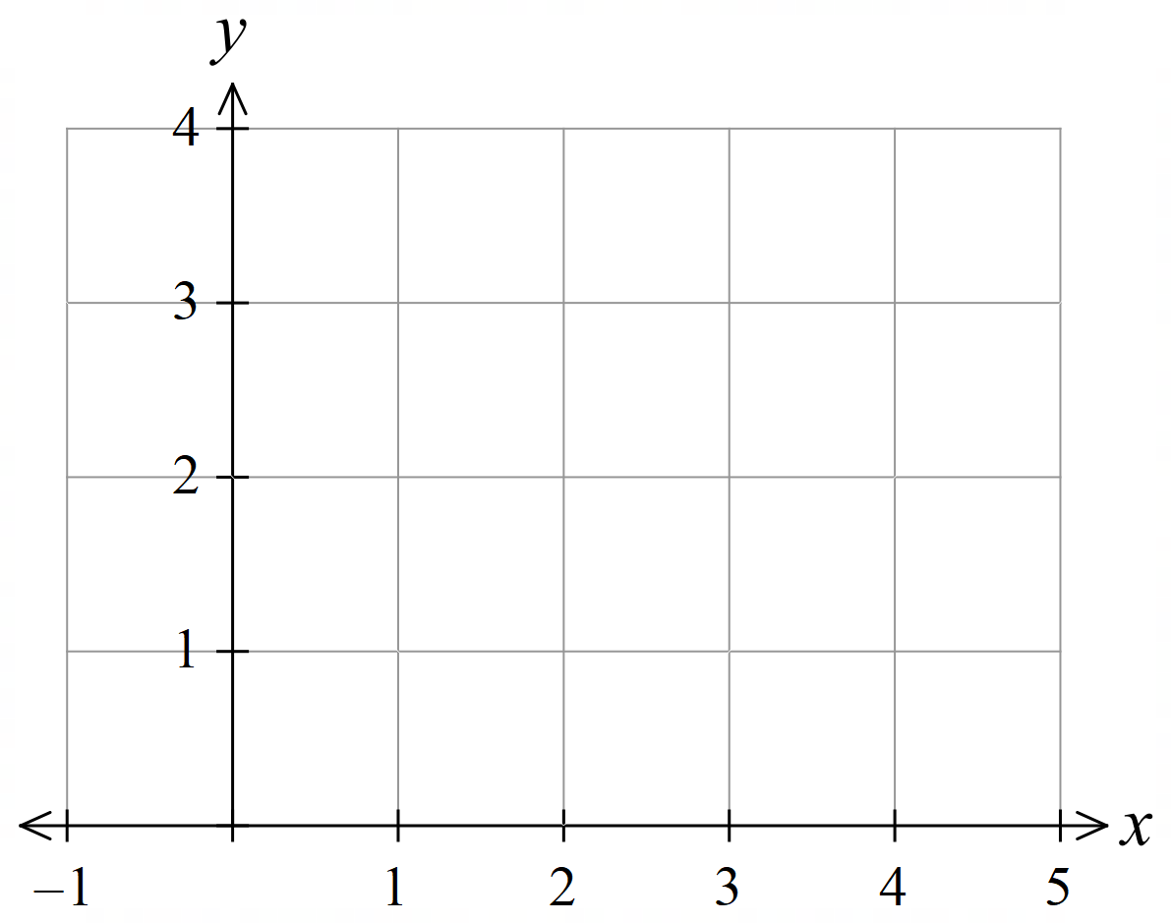

  - Find the equations of each “branch” of $y=\left|x-2\right|$ and label them on your diagram.

Left branch: $y=-x+2$
Right branch: $y=x-2$
  - Identify how the solutions of $\left|x-2\right|=$ $\frac{x}{3}$ are represented on your diagram.

The solutions are the $x$ coordinates of the points of intersection.
  - Hence, find the solutions of $\left|x-2\right|=$ $\frac{x}{3}$ and verify they work by substituting them back into the equation.

$$x=\frac{3}{2}. 3$$

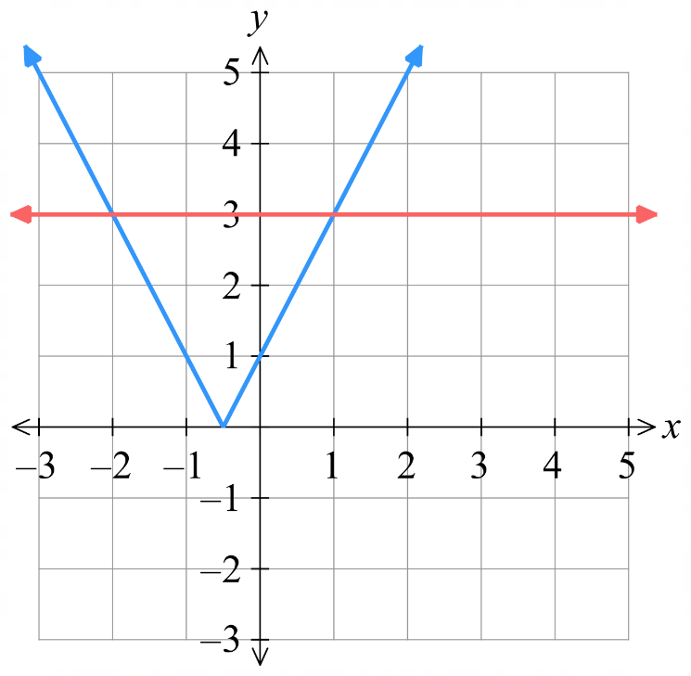
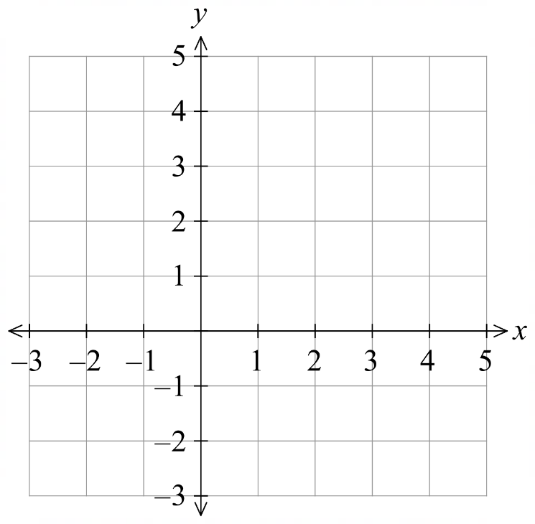
- Use a similar technique as the previous question to solve these equations graphically.
  - $|2x+1|=3$

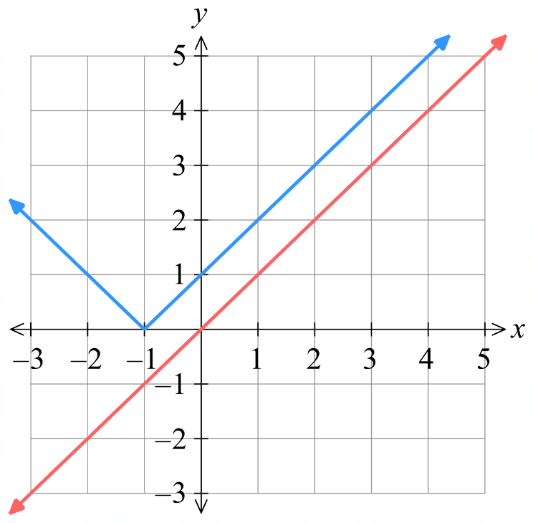
$$x=1,-2$$
  - $\left|x+1\right|=x$

No solution
  - $\left|2x+1\right|=3x$
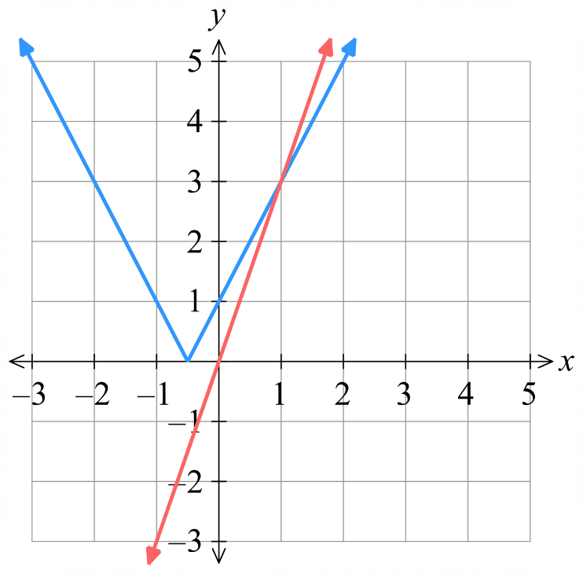

$$x=1$$

- This question shows a common pitfall of the algebraic method.
  - Solve $\left|2x+1\right|=3x$ by considering two cases.
You should get two solutions, $x=1$ and $x=-$ $\frac{1}{5}$.
$$2x+1=3x$$ | $$-\left(2x+1\right)=3x$$

  - However, by considering your answer to part c in the previous question, only $x=1$ is a solution.
Explain why $x=-$ $\frac{1}{5}$ is not actually a solution by:
Substituting it into the equation.  $$\left|-\frac{2}{5}+1\right|=-\frac{3}{5}$$  Is not possible as an absolute value cannot be negative. | Referring to the graphical representation.  There is only one point of intersection at $x=1$.  By solving the equation algebraically, we have extended the $-x$ branch beyond its domain, which is how we got an additional false solution of $x=-$ $\frac{1}{5}$

  - If you choose to solve an absolute value equation with $x$ on both sides algebraically, what should you do to ensure you don’t have any false solutions?

Substitute value(s) of $x$ back into original to see if they satisfy the equation.
- Solve these equations algebraically and check for valid solutions.
- $\left|x-5\right|=2x-6$  $$x=\frac{11}{3}$$ | - $\left|2x+1\right|=x$  No solution | - $\left|1-3x\right|=2x+4$  $x=-$ $\frac{3}{5}$ or $5$

Absolute Value Identities

- Square Roots and Absolute Value
The definition of a square root is:
$$\sqrt{x^{2}}=\left|x\right|$$

The square root symbol always gives a non-negative answer.
For example, when $x=-3:$ $\sqrt{{\left(-3\right)}^{2}}=\sqrt{9}=3$

- Be careful not to confuse evaluating a square root with solving an equation.
Evaluating Square Root  $\sqrt{9}=3$ | Solving Equation  $$x^{2}=9 \\ =±\sqrt{9} \\ =±3$$

- Example Use the square root absolute value identity
Solve $\sqrt{{\left(x-2\right)}^{2}}=5$  $$\left|x-2\right|=5$$  $x-2=5 or -\left(x-2\right)=5$  $x=7 -x+2=5$  $-x=3$  $x=-3$ | Solve $x^{2}=5$  $$\sqrt{x^{2}}=\sqrt{5}$$  $\left|x\right|=\sqrt{5}$  $±x=\sqrt{5}$  $x=±5$

- Guided Practice
Solve
- $\sqrt{{\left(2x+7\right)}^{2}}=7$  $$x=3, -4$$ | - $\frac{\sqrt{x^{2}}}{x^{2}}+1=6$  $$x=±\frac{1}{5}$$
- Absolute Value Identities
$$\left|-x\right|=\left|x\right| \\ \left|x-y\right|=\left|y-x\right| \\ \left|xy\right|=\left|x\right|\left|y\right| \\ \left|\frac{x}{y}\right|=\frac{\left|x\right|}{\left|y\right|} \\ \sqrt{x^{2}}=\left|x\right| \\ {\left|x\right|}^{2}=x^{2}$$

Foundation
- Simplify using $\left|-x\right|=\left|x\right|$.
- $\left|-a\right|$ | - $\left|-3x\right|$ | - $\left|-\left(x+2\right)\right|$ | - $\left|-\left(3x-1\right)\right|$


- Rachel says:
$\left|-x\right|=x$ because the absolute value removes the negative sign.

Explain why she is incorrect.

Consider if $x=-3$
Then the identity would give $\left|-\left(-3\right)\right|=-3$, which is not correct as the absolute value of an expression must be non-negative.
- Rewrite in an alternate form using and $\left|x-y\right|=\left|y-x\right|$
- $\left|5-x\right|$ | - $\left|2a-7\right|$ | - $\left|4-2x\right|$ | - $\left|y-\frac{x}{2}\right|$

- Simplify using $\left|xy\right|=\left|x\right|\left|y\right|$ and $\left|\frac{x}{y}\right|=\frac{\left|x\right|}{\left|y\right|}$
- $\left|3x\right|$ | - $\left|-5xy\right|$ | - $\left|\frac{x}{3}\right|$ | - $\left|-\frac{3}{2x}\right|$
- $\left|2x\left(x+1\right)\right|$ | - $\left|\frac{x-y}{x+y}\right|$ | - $\left|-x\left(x+5\right)\right|$ | - $\left|-\frac{x^{2}}{3y}\right|$

- Simplify each expression using $\sqrt{x^{2}}=\left|x\right|$ and ${\left|x\right|}^{2}=x^{2}$.
- $\sqrt{a^{2}}$ | - $\sqrt{9x^{2}}$ | - $\sqrt{{\left(x+3\right)}^{2}}$ | - ${\left|5x\right|}^{2}$
- ${\left|x-2\right|}^{2}$ | - $\sqrt{{\left(2x-1\right)}^{2}}$ | - $\sqrt{x^{4}}$ | - $\sqrt{{\left(a-b\right)}^{2}}$

- Simplify as much as possible, retain the absolute value sign where necessary.
- $\sqrt{{\left(-3x\right)}^{2}}$ | - $\left|-2x\right|\left|3x\right|$ | - $\frac{\left|6x\right|}{\left|2x\right|}$
- $\sqrt{{\left(x-4\right)}^{2}}+\left|4-x\right|$ | - ${\left|-3x\right|}^{2}$ | - $\sqrt{{\left(a-b\right)}^{2}}\left|b-a\right|$
- $\frac{\left|x^{2}y\right|}{\left|xy\right|}$ | - $\sqrt{{\left(2x+1\right)}^{2}}-\left|-\left(2x+1\right)\right|$
- Solve these equations.
- $\sqrt{{\left(x+3\right)}^{2}}=5$ | - $\sqrt{{\left(3x+2\right)}^{2}}=8$
- $\sqrt{{\left(x-4\right)}^{2}}+3=10$ | - $3\sqrt{{\left(x+2\right)}^{2}}-5=7$
- $\frac{\sqrt{{\left(4x-1\right)}^{2}}}{3}=5$ | - $2\sqrt{{\left(x-3\right)}^{2}}+4=16$
- $\frac{\sqrt{x^{2}}}{x^{2}}=2$ | - $\frac{\sqrt{{\left(3x\right)}^{2}}}{x^{2}}=9$
- $\sqrt{x^{2}}=x+6$ | - $\sqrt{{\left(x-2\right)}^{2}}=x+4$

